Press Release: Richard Bangs’ Adventures with Purpose
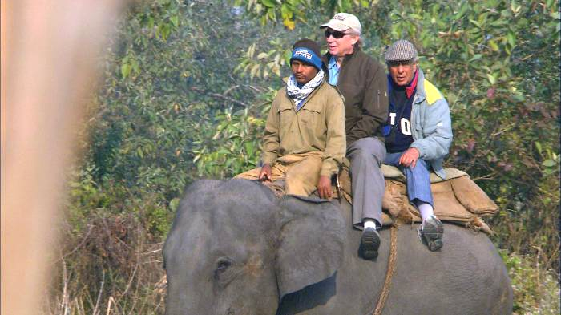
Richard Bangs’ Adventures with Purpose—Assam India: Quest for the One Horned Rhinoceros, a new, one-hour special from American Public Television, will air on _________ (station) _________________ at (time) _______, (day) __________ (date) _________. Hosted by Richard Bangs who is often called “the father of modern adventure travel,” Assam India: Quest for the One Horned Rhinoceros is the latest documentary in a series of adventure travel, eco-conscience, and historical specials. According to Bangs, “Adventures with Purpose not only quicken the pulse and fire the synapses, they are also journeys of enlightenment and discovery—odysseys that make a difference.”
Adventures with Purpose is produced by Small World Productions, the makers of Smart Travels—Europe and Pacific Rim with Rudy Maxa and Travels in Europe with Rick Steves. The specials are co-produced by KCTS/Seattle, and Richard Bangs Productions of Marina del Rey, California. KCTS is the presenting station to APT.

This time Richard Bangs is traveling in a remote state on the northeastern cusp of India called ‘Assam.’ It’s a throne-room of rushing rivers, raving monsoons and the most soothing of tea. But perhaps most thrilling of all, Assam is home to a staggering range of wildlife. One animal, the Indian one-horned rhinoceros, stands as a special symbol to the people here. Richard is off to find what the one-horned rhino means to the people of Assam, and why it flourishes here as in no other place.

Somewhere in the far, far reaches of India; in the shadow of the Himalayas; along the misty banks of the Brahmaputra River glides a grey blur that almost became a ghost—the one-horned rhinoceros. It’s a rare species that a hundred years ago nearly vanished from the face of the earth. What kept the rhino from falling into the chasm of extinction? In this documentary Richard examines what the rhino’s story can teach us about our world today; about saving precious wildlife, and—for that matter—all living things.

About the size of Ireland or Indiana, Assam is a fertile valley in northeastern India. It’s a sweep of farmland and wildlife ranges, peppered with cities and towns. We’ll begin our journey in Manas National Park, and travel to villages near Guwahati, Assam’s largest city. We’ll sail the great Brahmaputra River, visit Majuli Island, and end in Kaziranga National Park.

For many Westerners, India conjures images of frenetic cities, filled with economic extremes…Or daunting hikes up Himalayan slopes. But our focus this trip is different. The quiet state of Assam floats like a kite off the shoulder of mainland India. It’s a place of deep, rich culture, and conservation work that’s been remarkably successful

Rhinos once roamed the earth. Not long ago, Africa teemed with them, too many to count. But today that continent is almost empty of the tank-like beasts. While in Assam there are still tracks where thousands roam. What went right in Assam? What threats still exist, and what help is still needed? What can we learn?

Ultimately Richard concludes that Assam’s record is enviable, but going forward more help will be needed. New visionaries, like Richard’s guide Avinash Kohli, are stepping up to encourage visitors to come to Assam, to experience the wonder of these magnificent animals in this wild place, and to be part of a movement that sustains rhino footsteps far into the future.
(more…more…more)
Richard Bangs’ Adventures with Purpose
Press Release, Page 2

According to Bangs, Assam faces the same challenges as all other wildlife rich regions: population pressures, poachers, environmental degradation. Yet it enjoys elements that uniquely braid together to create a web of protection—empathy, faith and economics.

Assam is steeped in religion and philosophy that revere all life. And it has developed economic models that provide livelihoods in concert with nature, from tea growing to ecotourism.

Bangs concludes that nothing happens unless we dream, and Assam is a dream awakened.
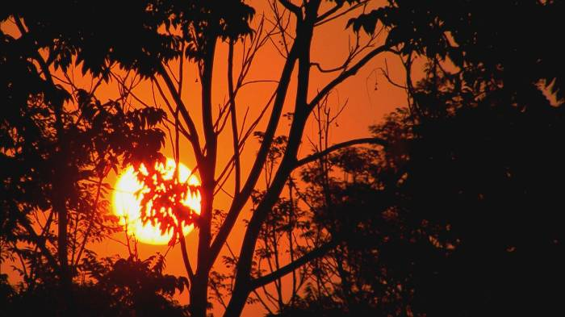
Host and co-executive producer, Richard Bangs is a pioneer in travel that makes a difference, travel with a purpose. He has spent 30 years as an explorer and communicator, and along the way led first descents of 35 rivers around the globe, including the Yangtze in China and the Zambezi in Southern Africa. Richard has published more than 1000 magazine articles, 18 books, a score of documentaries and CD-ROMs; and has lectured at the Smithsonian, the National Geographic Society, the Explorers Club and many other notable venues. He writes a semi-regular feature for the NY Times. His latest books include Adventures with Purpose, Quest for Kaitiakitanga, and Quest for the Kasbah, companion books for episodes in the television series.

Richard’s books and DVDs of Adventures with Purpose: Quest for the One-Horned Rhinoceros are available from Small World Productions. Each DVD contains the complete show and more than two hours of value added bonuses: Richard’s adventure travel tales, never-before-seen bonus footage, and behind the scenes glimpses. DVDs are $24.95 each plus shipping. Richard’s Adventures with Purpose books are $16.95 each plus shipping. The book and DVD together are $35.95 plus shipping. Viewers may order online at www.AdventuresWithPurpose.TV or call the order desk at 800.866.7425.

Small World Productions, Inc. of Seattle produces Richard Bangs’ Adventures with Purpose. KCTS/Seattle and Richard Bangs Productions are co-producers. KCTS is the presenting station. ExOfficio Travel Apparel and Adventure Link provided support for production and distribution of this special.

HDTV versions of Adventures with Purpose will be up-linked on the public television HD satellite transponder. An NTSC, or standard definition, “letterboxed” version, will air on hundreds of public television stations as well. Digital audio is transmitted in stereo.

About American Public Television
With more than 10,000 hours of programming in its library, American Public Television (APT) has been a prime source of programming for the nation’s public television stations for 48 years, distributing more than 300 new titles per year. In 2006, APT launched Create – the TV channel featuring the best of public television's lifestyle programming. Known for its leadership in identifying innovative, worthwhile and viewer-friendly programming, APT has established a tradition of providing public television stations with program choices that strengthen and customize their schedules, such as Rick Steves' Europe, Worldfocus, Globe Trekker, Simply Ming, Sara's Weeknight Meals, America's Test Kitchen From Cook’s Illustrated, Gourmet's Diary of a Foodie, Doc Martin, Lidia's Italy, Rosemary and Thyme, P. Allen Smith's Garden Home, Biz Kid$, Johnny Cash at Folsom Prison, Pavarotti: Salute Petra, The Best of the Jack Benny Show, Agatha Christie's Poirot, Spain...on the road Again, and other prominent documentaries, dramatic series, how-to programs, children’s series and classic movies. For more information about APT’s programs and services, visit APTonline.org.

